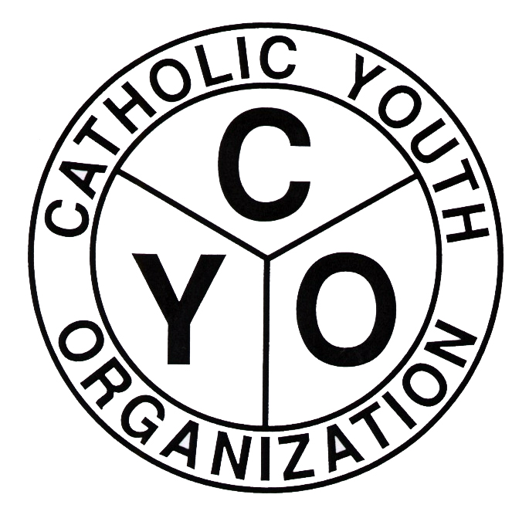
CATHOLIC YOUTH ORGANIZATION
Diocese of Brooklyn
7200 Douglaston PKWY – Douglaston, NY 11362
Tel: 718.281.9548/Fax: 718.281.9557

2019-2020 CYO SWIMMING ENTRY FORM
PLEASE PRINT OR TYPE ALL REQUIRED INFORMATION
THE PARISH OF______________________________________________WILL ENTER A TEAM IN THE 2019/2020 SWIMMING LEAGUE SPONSORED BY CYO.
BOYS_____________ GIRLS ___________________
TEAM NAME ____________________________________________________________
HEAD COACH'S NAME_____________________________________________________
ADDRESS_______________________________________________________________
HOME PHONE#_________________ CELL #______________________ E MAIL ____________________
**********************************************************************
PARISH ATHLETIC REPRESENTATIVE ATHLETIC DIRECTOR (Leave blank if same as Head Coach)
NAME ________________________________ _____________________________________
Address _______________________________ _____________________________________
_______________________________ _____________________________________
Home Phone # _________________________ _____________________________________
Cell Phone # ___________________________ _____________________________________
Email __________________________________ _____________________________________
ENTRY APPROVED BY: PASTOR SIGNATURE:_________________________________
PAR SIGNATURE: ____________________________________________
THIS FORM SHOULD BE RETURNED TO KEITH GOLDBERG BY:
- BOYS TEAMS – OCTOBER 11, 2019
- GIRLS TEAMS – DECEMBER 13, 2019

KEITH GOLDBERG, CYO COORDINATOR
CATHOLIC YOUTH ORGANIZATION
Diocese of Brooklyn
7200 Douglaston Parkway
Douglaston, NY 11362 Revised 9/16/19

